Project Planning Phase
Project Planning Template (Product Backlog, Sprint Planning, Stories, Story points)

Date | 19 February 2026
Team ID | LTVIP2026TMIDS66455
Project Name | Visualization Tool for Electric Vehicle Charge and Range Analysis
Maximum Marks | 5 Marks

Product Backlog, Sprint Schedule, and Estimation (4 Marks)
Use the below template to create product backlog and sprint schedule
Sprint | Functional  Requirement (Epic) | User Story  Number | User Story / Task | Story Points | Priority | Team  Members
Sprint-1 | Registration & Login | USN-1 | As a user, I can register for the application by entering my email, password, and confirming my password. | 2 | High | 4
Sprint-1 |  | USN-2 | As a user, I receive confirmation email after registration | 1 | High | 4
Sprint-1 | Vehicle Input Module | USN-3 | As a user, I can input battery %, vehicle model, and range preference | 3 | High | 4
Sprint-2 | Range Estimation | USN-4 | As a user, I can view estimated range on a visual map | 5 | High | 4
Sprint-1 |  | USN-5 | As a user, I can see alerts when range is critically low | 2 | Medium | 4
Sprint-2 | Charging Station Mapping | USN-6 | As a user, I can view nearby stations filtered by charger type and availability | 4 | High | 4
Sprint-3 | History & Analytics | USN-7 | As a user, I can view previous charge sessions with distance and cost data | 3 | Medium | 4
 |  | USN-8 | As a user, I can export session summaries for analysis | 2 | Low | 4

Project Tracker, Velocity & Burndown Chart: (4 Marks)
Sprint | Total Story Points | Duration | Sprint Start Date | Sprint End Date (Planned) | Story Points  Completed (as on  Planned End Date) | Sprint Release Date (Actual)
Sprint-1 | 20 | 6 Days | 19 February 2026 | 21 February 2026 | 20 | 22 February 2026
Sprint-2 | 20 | 6 Days | 19 February 2026 | 21 February 2026
Sprint-3 | 20 | 6 Days | 19 February 2026 | 21 February 2026
Sprint-4 | 20 | 6 Days | 19 February 2026 | 21 February 2026

Velocity:
Imagine we have a 10-day sprint duration, and the velocity of the team is 20 (points per sprint). Let’s calculate the team’s average velocity (AV) per iteration unit (story points per day)
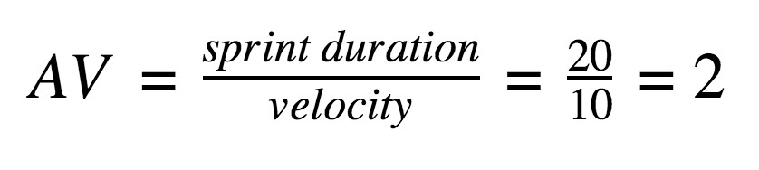

Burndown Chart:
A burn down chart is a graphical representation of work left to do versus time. It is often used in agile software development methodologies such as Scrum. However, burn down charts can be applied to any project containing measurable progress over time.

https://www.visua
l
-
paradigm.com/scrum/scru
m
-
burndow
n
-
chart
/

https://www.atlassian.com/agile/tutorials/burndow
n
-
chart
s

Reference:

t
https://www.atlassian.com/agile/projec
-
managemen
t

https://www.atlassian.com/agile/tutorials/ho
w
-
t
o
-
d
o
-
scru
m
-
wit
h
-
jir
a
-
softwar
e

https://www.atlassian.com/agile/tutorials/epic
s

https://www.atlassian.com/agile/tutorials/sprint
s

https://www.atlassian.com/agile/projec
t
-
management/estimatio
n

https://www.atlassian.com/agile/tutorials/burndow
n
-
chart
s

